**MINIMUM VIABLE PRODUCT(MVP).**

**PROJECT OF NYARKO PHILIP ABEL.**

The Minimum Viable Product (MVP) is a concept in product development that refers to a version of a new product that includes only the essential features required to meet the needs of early adopters and gather feedback for future development. The goal of an MVP is to quickly deliver a functional product to market with minimal effort and resources, allowing the development team to test the product hypothesis and gather valuable insights.

The key characteristics of an MVP include:

* Core Functionality: The MVP includes only the most essential features that address the primary problem or need of the target audience.
* Quick Development: The development time for an MVP is kept to a minimum, allowing for a rapid launch and iteration based on user feedback.
* Learning and Feedback: The main purpose of an MVP is to learn from user interactions and feedback. This information helps refine the product and make informed decisions about future development.
* Cost-Effectiveness: By focusing on the core features, an MVP reduces development costs and allows for a more efficient use of resources.
* Iterative Development: After the initial release of the MVP, subsequent versions are developed based on user feedback and evolving requirements.

**Architecture Concepts**

Architecture is defined as the complex or carefully designed structure of something or the art or practice of designing and constructing buildings.

**Learning Structure on MVP**

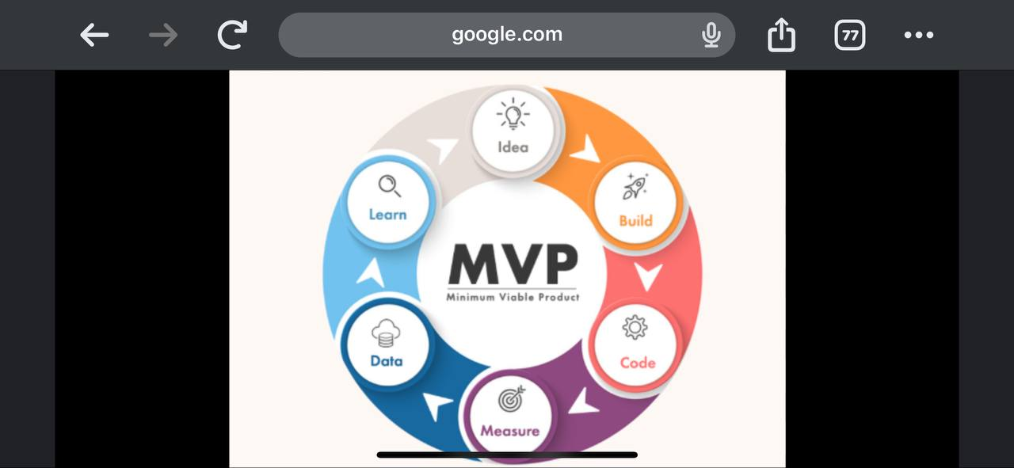

* The above MVP explains An Idea to brainstorm,its Building, the Code to illustrate the learning objectives , the Measure of that Idea illustrated and a Data stored to make meaning out of the Learning MVP.

What is Data Modeling?

**Data modeling is the process of creating a visual representation of either a whole information system or parts of it to communicate connections between data.**

| **Products** |  | **Customer’s Names** | **Payment status** |
| --- | --- | --- | --- |
| **Milo** |  | **Cynthia** | **Paid** |
| **Sugar** |  | **Thomas** | **To be paid on delivery** |
| **Rice** |  | **Princess** | **paid** |

**USER STORIES**

A user story is an informal, general explanation of a software feature written from the perspective of the end user. Its purpose is to articulate how a software feature will provide value to the customer. It's tempting to think that user stories are, simply put, software system requirements.

The user story is like a mantra that kicks off the learning experience process. Let it guide you through the entire project. Keep it someplace highly visible to you and your team, and refer to it frequently. This ensures that you value the learner's voice through every project step.

In the above structure of my Learning MVP, it is obvious that learning starts with having an Idea of the subject matter of what one wants to learn. The Idea is followed by Building a system to make it easier for learning objectives to be achieved. Such as learning easier topics before topics involving calculations. This is followed by developing Code alternative measures in making learning easier . This aspect makes use of having a time table to suit the learning objectives .There is the need to weigh by Measuring the codes to determine which works perfectly. At this stage, the student tries to remember what he or she has learnt by recalling what has been learnt. As far as the measurement is rightly done, there is the need to explain the process off head without difficulties. This process is called Information (Data). This final aspect deals with providing the answers to questions learnt on the topics under discussion.

**Mock-up**

A mock-up model or replica of a machine or structure, used for institutional or experimental purposes.



# 

# **MVP COMPLETE**

Assessments for corporate learning don’t always have to be a direct line from cause to effect. Training ROI has always been notoriously difficult to track, so you’ll need a more holistic approach to fully grasp the spectrum of growth and development after a new training initiative. Here are some of the best ways to make your assessments more meaningful, human, and effective.

### #1 – Set clear expectations.

Give learners an idea of what they can expect along their learning path. If you intend to test at the end of each module, tell learners so they understand those assessment parameters before getting started. Use a progress map or slider bar to show proficiency expectations and give a visual representation of their progress. That way, if they fall short, they’ll know where and when they need to improve.

### #2 – Create adaptive assessment opportunities.

Approach assessments as part of an individual measure, rather than a static feature. Instead of a linear learning path, allow assessment results to prescribe a more individual path; learners can skip ahead when they’ve already mastered a skill or double back to focus on weaker topics, for example. Assessments should serve as a way to keep users moving forward to their learning target, even if the path requires a detour or shortcut along the way.

### #3 – Switch up assessment types.

Utilize different types of assessments to keep learners engaged and constantly receiving new insights for more impactful experiences. Taking the same true or false quiz at the end of each chapter might prove proficiency, but it doesn’t do much for engagement. Switch it up and use the assessment types that will deliver users the best, most meaningful feedback you can offer.

### #4 – Give real-time feedback.

Don’t wait until the end of a training program to tell learners how they did. Real-time feedback is one of the most effective tools in helping to adapt their behavior and build stronger foundational knowledge. The combination of motivation and course-correction makes real-time feedback more inspirational than generic scores or a simple pass or fail.

### #5 – Analyze the results.

Offering more impactful learning assessment opportunities puts the individual learner at the center of each program and allows you to focus on personalized paths and outcomes. Still, those same assessments offer valuable analytics for your organization, so don’t miss the opportunity to view assessments from an executive lens as well. Whether you collect assessment results through your LMS or utilize surveys and team feedback, the more meaningful the personal assessments are to each learner, the more valuable the data is for your entire organization.

Assessments don’t have to be designed around yes and no, right and wrong, or true and false. By thinking beyond traditional assessment methods and taking a more individual approach to training evaluation, your learners get more out of every topic.

Make assessments forlearning more meaningful by putting less emphasis on the right and wrong of it all; focus more on growth and development so each assessment is more motivational tool than measuring stick.